**A PROJECT REPORT**

**LIBRARY MANAGMENT SYSTEM**

**Submitted by:**

**MD FOYSAL AHMED**

**IFFAT TASIN**

**SALAUDDIN AHMED**

**MD. SHAFIUL AZAM**

**CSE 100: Software Development Project I**

**DEPARTMENT OF COMPUTER SCIENCE ENGINEERING**

**BANGLADESH UNIVERSITY OF BUSINESS AND TECHNOLOGY (BUBT)**

**DHAKA BANGLADESH**

**NOVEMBRE, 2022**

**TABLE OF CONTENTS**

|  |  |
| --- | --- |
| **Lesson** | **Page** |
| 1. **DECLARATION** 3 | |
| 1. **ACKNOWLEDGEMENT** 3 | |
| 1. **ABSTRACT** 3 | |
| **CHAPTER-1: INTRODUCTION** 4-6 | |
| 1.1 Introduction 4 | |
| 1.2 Motivation for library management 4 | |
| 1.3 Current system of library management 4 | |
| 1.4 Problem of the current system of library 4 | |
| 1.5 Propose system of library management 4 | |
| 1.6 Project overview 5 | |
| 1.7 Scope of the library management system 6 | |
| Chapter-2: **LITERATURE REVIEW** 6-7 | |
| 2.1 Introduction 6 | |
| 2.2 Technological Components 6 | |
| 2.3 Algorithm / Methodology 7 | |
| Chapter-3: **REQUIREMENT ANALYSIS** 7-9 | |
| 3.1 Requirement Analysis 7 | |
| 3.2 Hardware requirement analysis 8 | |
| 3.3 Software requirement analysis 9 | |
| 3.3.1 Visual Studio Code 9 | |
| 3.3.2 Code Block 20.3 9 | |
| Chapter-4: **SYSTEM ANALYSIS AND DESIGN** 9-10 | |
| 4.1 Flowchart 9-10 | |
| Chapter-5: **IMPLEMENTATION AND TESTING** 11 | |
| 5.1 Introduction 11 | |
| 5.2 Manu 11 | |
| 5.3 Content 11 | |
| 5.4 Testing and analysis 11 | |
| Chapter-6: **USER MANUAL** 12 | |
| 6.1 Introduction 12 | |
| Chapter-7: **REFERENCES** 12 | |
| **FORMATION DOCUMENT** 13 | |

**DECLARATION**

I hereby declare that the project entitled “Library Management System” submitted for the completion of CSE 100: Software Development Project I course in the faculty of Computer Science and Engineering of Bangladesh University of Business and Technology (BUBT), is our original work and that it contains no material which has been accepted for the award to the candidates of any other degree or diploma, except where due reference is made in the next of the project to the best of our knowledge, it contains no materials previously published or written by any other person except where due reference is made in this project.

**Iffat Tasin**

**ID:21225103129**

**Intake: 49**

**Section: 3**

**MD. Faysal Ahmed**

**ID:21225103124**

**Intake: 49**

**Section: 3**

**MD. Shafiul Azam**

**ID:21225103132**

**Intake: 49**

**Section: 3**

**Salauddin Ahmed**

**ID:21225103131**

**Intake: 49**

**Section: 3**

**ACKNOWLEDGEMENT**

We have taken efforts in this project. However, it would not have been possible without the kind support and help of many individuals. We would like to thank all of them.

We are sincerely thankful to our project guide Md. Masudul Islam, Assistant professor in Bangladesh University of Business and Technology (BUBT) for his guidance and constant supervisions as well as providing necessary information regarding the project. We feel honored to work under his guidance. This project would not have been possible without his guidance.

**ABSTRACT**

Library management system is a project which aims in developing a computerized system to maintain all the daily work of library. It also has a facility of admin login password through which the admin can monitor the whole system. This system will store all the books and members information that consist book numbers, book titles, author names and racks to the system database. It also provides search function to help students find the book by number of books. Search function will search through the books database to look for the book and view where the book is situated. Overall, this project is being developed to help the students as well as staff of library to maintain the library in the best way possible and also reduce the human efforts.

**CHAPTER-1**

**INTRODUCTION**

**1.1 INTRODUCTION**

Library Management System is a term for computer-based system that manage the catalogue of a library. The main purpose of this system is to manage library daily operation efficiently.

**1.2 MOTIVATIONS FOR LIBRARY MANAGEMENT**

The library as an integral and significant part of educational system has undergone phenomenal development in the use of ICTs which have substantial influence in the process of information resources’ acquisition, processing, storage and use in developing countries. Consequently, libraries are required to provide access to huge information resources in diverse format such as print books and electronic format (e-books, e-journals/journal articles, CD-ROMs, Internet resources/services) as well as bibliographical information about these resources have influenced the adoption of LMS (Library Management System).

**1.3 CURRENT SYSTEM OF LIBRARY MANAGEMENT**

At present, books are issued to students in the analog system in the library, generally the books are issued by writing date and return date in the register book. And it is taken back on the due date, so there is a possibility of the book getting lost at times. In some cases, books are not even available due to non-registration.

**1.4 PROBLEM OF THE CURRENT SYSTEM OF LIBRARY**

At present, by dealing with books in analog system, it is seen that even though there are books, students cannot take the books because of lack of correct information, many times it is seen that the books of each rack are kept in other racks for which the books cannot be found, so the books have to be bought again. Again, the register book is used in the case of giving and taking books to students, where students have to write their name, roll, date of collection and return date, many times, due to not checking the register book, the book return date is passed, so there is a high possibility of losing the book.

**1.5 PROPOSE SYSTEM OF LIBRARY MANAGEMENT**

The proposed system was made based on the wants and needs of the school, the system consists of registering books with specific book identification number, so that the librarian has an easy access in each book, search tabs for reliable, easy and faster monitoring of books and more importantly a report and evaluation papers can be generated in a well-organized and well-presented reports. Each student is limited to borrow one book every transaction to provide each student an equal chance of borrowing specific books**.** The system is developed to cope up with the current issues and problems of library. The system can add user, validate user and is also bug free. Save time After computerized system is implemented less human force will be required to maintain the library thus reducing the overall cost.

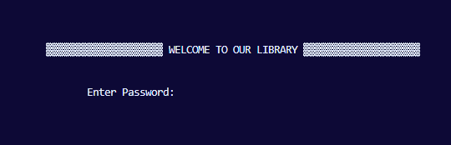**1.6 PROJECT OVERVIEW**

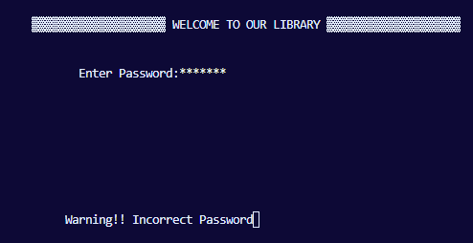



**If incorrect Password Show This Massage**

**Input The Password**

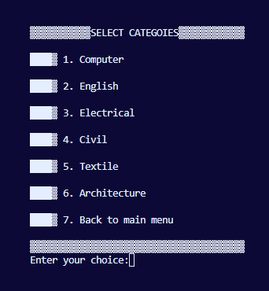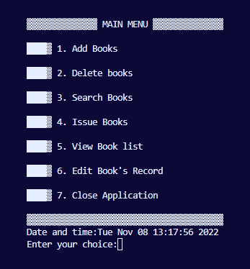

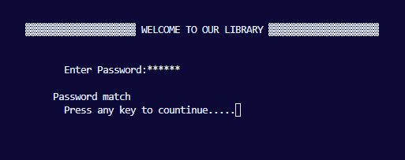



**Correct Password So Permission to Entry**

**This Is Our Library**

**Menu Interface**

**We Can Add Books**

**In This Way And Select Categories**

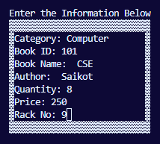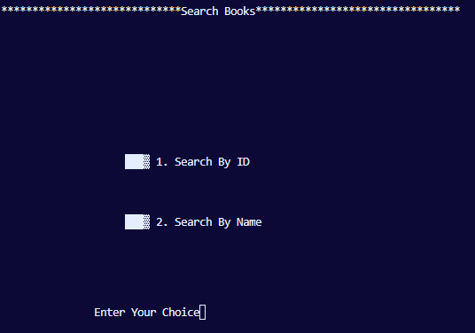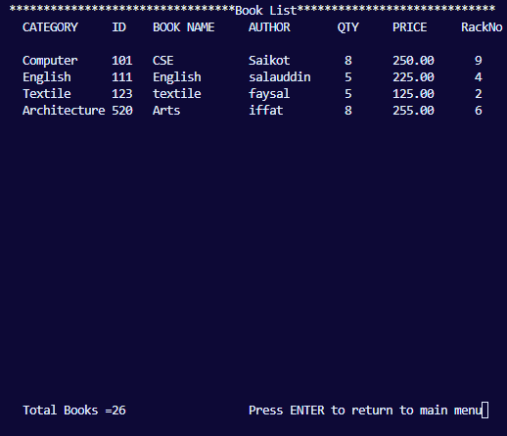

**We Can View Book List**

**We Can Search Books with Books ID And Name**

**Add Book Processing**

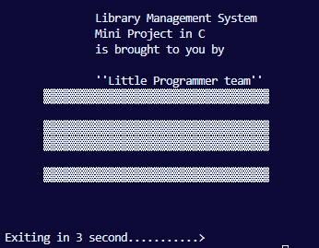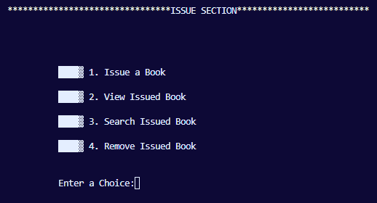

**We Can Issue Books**

**If All Works Are Done, We Can Closed This**

**Can Search Books**

**Books Id And Name**

**Can Issue Books**

**View Books list**

**1.7 SCOPE OF THE LIBRARY MANAGEMENT SYSTEM**

Scope of the current system This system is only limited to the students of St. Columban’s Academy in which the needs of borrowing books in the library increase yearly. As the number of students grow the number of demands in borrowing of books in the library is also growing. This system is performed manually the recording of books being borrowed, returned, damaged etc, that is ideal only for a small demand of students this current system is the best and most ideal thing to be done to provide track records in each transaction.

For Members: -

* Facility for search of Books based on Access name and book id.
* Facility for ISSUE / RETURN Books.
* Facility for RENEWAL of Books.

For Library Staff: -

* Login with password
* Add books
* Delete books
* Search books
* Issue books
* Views books
* Edit books records
* Close Application simply,

**Chapter-2**

**LITERATURE REVIEW**

**2.1 INTRODUCTION**

Computer Science, its related fields and Information and Vocational practice, cut

across every academic discipline, corporate organization and all spheres of human

endeavors because of its broadness, indispensability and uniqueness. This section

therefore contains a review of studies and Works that relate to this study. Reviews

of the related literature were done under the following headings:

- Computer Science Technology Infrastructure

- Meaning Of Computer Science Technology

- The Need for an effective computer science technology infrastructure

- Computer science (ICT) and Vocational Development

- Basic effects of computer (ICT) component (Internet Facilities)

- The need for an effective and modern approach to teaching computer science

technology.

- Reasons for Vocational adaptation of Computer Science Technology (ICT

Practice) for Educational purposes.

- Vocational sector and its usefulness

Computer Science, its related fields and Information and Vocational practice, cut

across every academic discipline, corporate organization and all spheres of human

endeavors because of its broadness, indispensability and uniqueness. This section

therefore contains a review of studies and Works that relate to this study. Reviews

of the related literature were done under the following headings:

- Computer Science Technology Infrastructure

- Meaning Of Computer Science Technology

- The Need for an effective computer science technology infrastructure

- Computer science (ICT) and Vocational Development

- Basic effects of computer (ICT) component (Internet Facilities)

- The need for an effective and modern approach to teaching computer science

technology.

- Reasons for Vocational adaptation of Computer Science Technology (ICT

Practice) for Educational purposes.

- Vocational sector and its usefulness

Computer Science, its related fields and Information and Vocational practice, cut

across every academic discipline, corporate organization and all spheres of human

endeavors because of its broadness, indispensability and uniqueness. This section

therefore contains a review of studies and Works that relate to this study. Reviews

of the related literature were done under the following headings:

- Computer Science Technology Infrastructure

- Meaning Of Computer Science Technology

- The Need for an effective computer science technology infrastructure

- Computer science (ICT) and Vocational Development

- Basic effects of computer (ICT) component (Internet Facilities)

- The need for an effective and modern approach to teaching computer science

technology.

- Reasons for Vocational adaptation of Computer Science Technology (ICT

Practice) for Educational purposes.

- Vocational sector and its usefulness

CHAPTFR TWO

LITERATURE REVIEW

Introduction

Computer Science, its related fields and Information and Vocational practice, cut

across every academic discipline, corporate organization and all spheres of human

endeavors because of its broadness, indispensability and uniqueness. This section

therefore contains a review of studies and Works that relate to this study. Reviews

of the related literature were done under the following headings:

CHAPTFR TWO

LITERATURE REVIEW

Introduction

Computer Science, its related fields and Information and Vocational practice, cut

across every academic discipline, corporate organization and all spheres of human

endeavors because of its broadness, indispensability and uniqueness. This section

therefore contains a review of studies and Works that relate to this study. Reviews

of the related literature were done under the following headings:

CHAPTFR TWO

LITERATURE REVIEW

Introduction

Computer Science, its related fields and Information and Vocational practice, cut

across every academic discipline, corporate organization and all spheres of human

endeavors because of its broadness, indispensability and uniqueness. This section

therefore contains a review of studies and Works that relate to this study. Reviews

of the related literature were done under the following headings:

Computer Science, its related fields and Information and Vocational practice, cut across every academic discipline, corporate organization and all spheres of human endeavors because of its broadness, indispensability and uniqueness. This section therefore contains a review of studies and Works that relate to this study.

**2.2 TECHNOLOGICAL COMPONENTS**

* Computer, Laptop, MacBook Pro.
* Processor- Intel Core I 3 6th gen, Core I 5 7th gen, Core I 7 7th gen.
* RAM- 16gb, 8gb, 8gb.
* Mother Board- Gigabyte H450, Gigabyte H320, Retina Early 2018.
* Display- Monitor 1920x1080 120 GHz, 1600x1024 95GHz.
* SSd-250gb, SSD-120gb, Hard Disk -500gb, SSD-560gb, CD-ROM, keyboard, Mouse

**2.3 ALGORITHM / METHODOLOGICAL**

This chapter begins on the scrutiny about the project research design methodology together with the development of the system operation, process and testing. The second part discussed the architectural diagram interface of hardware and the last part showed the recommended hardware, software and network specification.

Maintenance

Operation Test

Testing Code

Planning

Coding

Discussing

Analysis

Throughout the project making after the researchers conducted interviews and research regarding the proposed system, the researchers have decided to use Waterfall Model for the Software Development Project (SDP),because this model gave the researchers lot of advantage including; in each stage and activity done in development of the project those stages and activities were easily explained which benefit both the researchers and the client and also in each verification and review of each stage can easily locate and repair errors that may occur in the program.

**Chapter-3**

**REQUIREMENT ANALYSIS**

**3.1 REQUIREMENT ANALYSIS**

The proposed computerized Library Borrowing System was designed purely from the users’ viewpoint without considering the restraint of hardware (such as computers hardware and software). In addition, system frameworks required to attain such designs was clarified. After checking requirement specifications included in the basic plan, the overview of the project was represented through the use of diagrams so that the alternation and flows of data can be easily assumed.

**3.2 HARDWARE REQUIREMENT ANALYSIS**

* **Possessor-** A processor is an integrated electronic circuit that performs the calculations that run a computer. A processor performs arithmetical, logical, input/output (I/O) and other basic instructions that are passed from an operating system (OS). Most other processes are dependent on the operations of a processor. The terms processor, central processing unit (CPU) and microprocessor are commonly linked as synonyms. Most people use the word “processor” interchangeably with the term “CPU” nowadays, it is technically not correct since the CPU is just one of the processors inside a personal computer (PC).
* **RAM-** RAM refers to Reliability, Availability, and Maintainability. RAM analysis is a well-known method of estimating the production availability of a system by assessing failure modes, frequencies and consequences, all the while paying attention to the effect on production.
* **Mother Board-** A motherboard refers to a Printed Circuit Board (PCB) which has an extended capacity. Today, it has become the most important component found nearly in all modern computers all over the world. As a holder, the motherboard acts as a major point of connection in which most of the main components of the computer like the Central Processing Unit (CPU), Random Access Memory (RAM), and the Complementary Metal Oxide Semi-Conductor (CMOS) are attached (Wikipedia, 1961).
* **Display-** A monitor or display is an electronic visual aid display for a computer. A monitor usually consists of display device, circuit, housing, and power supply. Mostly used as the main output device of the computer. A monitor generally refers to a large device such as a television, but in technology the concept of monitor is also used in a broader sense. A monitor is a tool that directly monitors the processes running on the system.
* **SSD/HHD-** A solid-state drive (SSD) is a new generation of storage device used in computers. SSDs store data using flash-based memory, which is much faster than the traditional hard disks they've come to replace. SSDs also have no moving parts, and upgrading to one is a great way to speed up your computer and make it more resilient. Learn how SSDs work and how to keep them optimized with performance-boosting software.
* **CD-ROM -CD-ROM**, abbreviation of **compact disc read-only memory**, type of computer memory in the form of a compact disc that is read by optical means. A CD-ROM drive uses a low-power laser beam to read digitized (binary) data that has been encoded in the form of tiny pits on an optical disk. The drive then feeds the data to a computer for processing.
* **Keyboard, Mouse -** A keyboard is one of the primary input devices used with a computer. Similar to an electric typewriter, a keyboard is composed of buttons used to create letters, numbers, and symbols, and perform additional functions. A mouse is a small handheld input device that controls a computer screen's cursor or pointer in conjunction with the way it is moved on a flat surface. The mouse term name originates from its likeness to a small, corded and elliptical shaped device that looks like a mouse tail.

**3.3 SOFTWARE REQUIREMENT ANALYSIS**

* **Visual Studio Code**
* **Code Block 20.3**

**3.3.1 Visual Studio Code**

Visual Studio Code has a high productivity code editor which, when combined with programming language services, gives you the power of an IDE and the speed of a text editor. In this topic, we'll first describe VS Code's language intelligence features (suggestions, parameter hints, smart code navigation) and then show the power of the core text editor.

**3.3.2 Code Block 20.3**

A **code block**, sometimes referred to as a compound statement, is a lexical structure of source code which is grouped together. Blocks consist of one or more declarations and statements. A programming language that permits the creation of blocks, including blocks nested within other blocks, is called a block-structured programming language. Blocks are fundamental to structured programming, where control structures are formed from blocks.

**Chapter-4**

**SYSTEM ANALYSIS AND DESIGN**

* **Information systems**
* **Code analysis and design**
* **System maintenance**
  1. **FLOWCHART**

**Chapter-5**

**IMPLEMENTATION AND TESTING**

**5.1 INTRODUCTION**

System Testing and Implementation In order to make this project successful, the researchers let the proponents test and evaluate Library Management System in order to receive feedbacks and to produce a reliable and effective system. Library Borrowing System was tested in the school laboratory by the proponents. Library Borrowing System is a customized system which is designed from the client’s desire in the system to make it more user friendly to the target users. The items below are the features included in the system.

**5.2 MANU**

Library Borrowing System Features This Library Borrowing System will feature the following:

• Computerized Admin / Librarian

• Secure storage books and details.

• Easy book borrowing and issued.

• Generating well-organized reports.

**5.3 CONTENT**

A Content Library Management System (CLMS) is a combination of large database and file system which are used to store and later retrieve huge amounts of data. At the college level, the Library Content Management System stores and manages the college’s electronic documents, journals, magazines and other resources so that the students and faculty members of the college can reuse the information across different applications. It is used to organize and facilitate collaborative content creation. The basic idea behind a Library CMS (Content Management System) is to separate the content management from design. Page designs are stored in templates while the content may be stored in a database or separate files.

**5.4 TESTING AND ANALYSIS**

After finishing the main parts of transaction being done in the system the researchers tested it and there was a lot of learning that the researchers encountered, it made the researchers realized minor and major mistakes in the system and it gave more understanding on how to done it, the system has been successfully introduced. The proposed computerized library borrowing system was designed purely from the users’ viewpoint without considering the restraint of hardware (such as computers hardware and software). In addition, system frameworks required to attain such designs was clarified. After checking requirement specifications included in the basic plan, the overview of the project was represented through the use of diagrams so that the alternation and flows of data can be easily assumed.

Chapter-6

**USER MANUAL**

**6.1 INTRODUCTION**

We can open our application by password. Here we can add books in different categories, their name, book code, how much price, which rack is available, we can also keep input. We can delete unnecessary books, we can search the books very easily, through the book code, for students we can issue and if we return the book we can delete it from the issue list, when all the work is done, we can come out of the application through exit option, then the application will be closed within 3 seconds.

Chapter-7

**REFERENCES**

1. <https://www.cppbuzz.com/projects/c/library-management-in-c>
2. <https://www.codewithc.com/mini-project-in-c-library-management-system/>
3. <https://code-projects.org/library-management-in-c-programming-with-source-code/>
4. <https://www.youtube.com/watch?v=PmMF0UjmYj0>
5. <https://www.tutorialspoint.com/write-a-c-program-of-library-management-system-using-switch-case>
6. <https://www.geeksforgeeks.org/e-library-management-system/>
7. <https://www.sourcecodester.com/cc/14851/library-management-system-using-c-source-code.html>
8. <https://www.youtube.com/watch?v=hYMkOFHrcxQ&t=5s>
9. <https://www.youtube.com/watch?v=rwud6rtmB2I>
10. <https://www.youtube.com/watch?v=wEmzyepukxg>
11. <https://www.youtube.com/watch?v=HP0oHeZgjHk>
12. <https://www.youtube.com/watch?v=wbs-9Jt5vUw>
13. <https://www.youtube.com/watch?v=RT_MGEcnHg4&list=PLE8jJwiAlPPrdN2VGrF9cz_8Owt4uvOUH>
14. <https://www.youtube.com/watch?v=u1e0gLoz1SU>
15. The c programming language (2nd edition)
16. C Programming Absolute Beginner’s Guide
17. C Programming in easy steps, 5th Edition
18. [**C Programming: A Modern Approach**](http://geni.us/vFmod8)
19. [Data Structures Using C](https://www.mygreatlearning.com/blog/c-programming-books/#9)
20. [Computer Fundamentals and Programming in C](https://www.mygreatlearning.com/blog/c-programming-books/#10)

**FORMATTING DOCUMENT**

It is important to pay particular attention to the structure, style, and presentation of your reports. While you prepare your report follow the guidelines for formatting the document.

|  |  |
| --- | --- |
| **Section** | **Description** |
| **Font** | * Use Times New Roman |
| **Margin** | * 1” top, bottom and right**. 1.5**” in left margin. |
| **Font Size** | 1. 16 size font, bold and upper case for chapter titles. 2. 14 font size, bold for chapter headings and 3. 12 for normal text. |
| **Line Spacing** | 1. 1.5 point throughout main text. 2. One blank line before and after all chapter titles and 3. One blank line before and after all left margin chapter headings 4. Leave blank line between paragraphs. |
| **Indenting** | * The first line of every paragraph in the text must be indented. |
| **Alignment** | Align text to Justify |
| **Page Numbering** | 1. Use lower case Roman numerals for the preliminary page (e.g. Title page, Abstract, Acknowledgements,). 2. Arabic numbering for main text and place at bottom center of page in the format – Page 1 of N. 3. No page numbering in Table of Contents |
| **Title** | * Font size 22, bold and centered. |
| **Author details** | * Font Size 14, bold and centered |
| **Chapter titles/Chapter heading** | 1. Number the chapter titles like 1,2,3,4, |
| 1. Number the Chapter heading: (e.g. 1.1,1. 2.) |
| **Tables and figure** | 1. Write something about each figure and table 2. Number all tables and figures, even if you use only one of each 3. Place caption above tables, number them and refer them in the text as Table 1, Table 2 etc. 4. For figure place captions below figures, number them and refer them in the text as Figure 1, Figure 2 etc. 5. Keep titles brief but informative 6. positioned as close to the relevant text as possible 7. Put graphs, tables, figures and diagrams in the Results section and complex raw data in the Appendix 8. A table or figure from an outside source should be labelled like any other outside information and its source should be provided. |